The Mall in St. James’s Park
32-bar strathspey for three couples in a three-couple longwise set

1 | – | 8 |  | 1st couple set, cross right hand, cast off one place, advance in the middle and pull right shoulder to face first corners.
9 | – | 16 |  | 1st couple turns first corner both hands, pass each other right shoulder, turn second corners both hands and pass each other right shoulder to finish on own lines.
16 | – | 22 |  | 2nd, 1st and 3rd couples dance parallel reels of three in six bars on the lines, 1st man giving left shoulder to 3rd man and 1st woman giving right shoulder to 3rd woman.
23 | – | 24 |  | 1st and 3rd men exchange place left shoulder while 1st and 3rd women exchange place right shoulder.
25 | – | 32 |  | 3rd and 1st couples dance the Poussette.
 |  |  |  | Repeat from new positions.

Devised by Nicolas “Niols” Jeannerod in 2018. The name was suggested by Christophe Schuwey in reference to the painting of the same name by Thomas Gainsborough.

Recommended music: The Mall in St. James’s Park, by Nicolas “Niols” Jeannerod.

The Mall in St. James’s Park
32-bar strathspey by Nicolas “Niols” Jeannerod

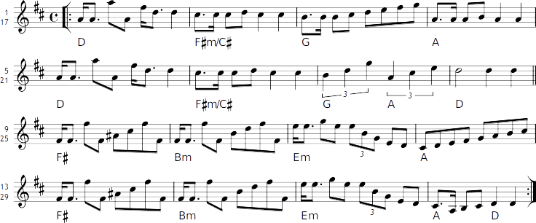

Copyright © 2018 Nicolas “Niols” Jeannerod.

